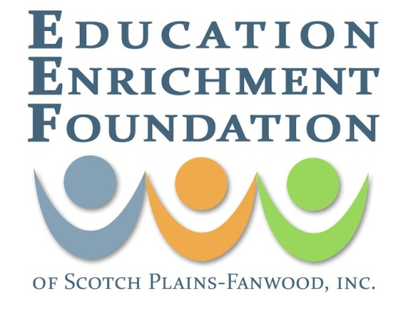
2022 – 2023 EDUCATOR GRANT APPLICATION

The purpose of the Educator Grant is to fund proposals from educators, school, subject area or student collaborators, who have innovative and creative ideas that will to inspire and strengthen the learning experiences of SPF students. Grants may not be used to compensate educators or purchase general school supplies or food. Grant funding is for the 2022-2023 school year, with possible implantation in spring 2022. In previous years, awards have ranged from $150 to more than $2000. Recipients of Educator Grants will be asked to provide periodic updates as their project progresses.

Please complete the following to submit electronically. Grants are evaluated anonymously, and budget information must be provided. Please do not identify yourself or your school.

Pages may be added as needed.

Project Title:
Please name your proposed project.

Summary of Project:
What is the primary objective of the project? The reader should also know the “who, what, where, when, and why” after reading the summary.

Need for Project:
What need(s) will this project meet? How does it promote a spirit of innovation?

Target Group:
Describe those who will be the recipients of your project. Be specific by including grade(s) and the number of students involved. Remember not to identify your school.

Personnel:
Describe the staff (by title) who will be involved and what their roles will be. Please do not use the names of the school or the people.

Activities:
Please explain how will you reach the objectives and provide a tentative timeline to reach those objectives.

Special features of the Grant:
Are materials reusable? Can the grant be expanded to others? Please provide any additional information you want the committee to consider.

Evaluation:
Describe how the success of the project will be evaluated. If appropriate, include any rubrics that may be used for assessment.

What excites you about this project:

BUDGET (Required)
Add price quotes, links, and backup documentation as needed. Non-consumable equipment or materials purchased through this grant becomes property of the Scotch Plains-Fanwood Public School District.

MATERIALS/SUPPLIES/EQUIPMENT DESCRIPTION: | AMOUNT
 | $
OTHER INFORMATION/COST TO SHARE: | AMOUNT
 | $
TOTAL: must include dollar amount | $
WILL YOU ACCEPT PARTIAL FUNDING*? | YES NO
WHAT IS THE MINIMUM REQUIRED TO EXECUTE THIS PROJECT  (*Required funding amount if you will accept partial funding). | $

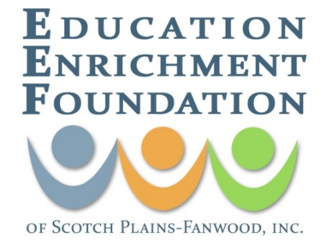
GRANT APPLICATION COVER SHEET

This cover sheet will be separated from the grant application. Be sure to provide the email address of at least one contact below.

Applicant Name(s):
Project Title:
School(s)/Program(s) and Grade(s):
Brief Description of Purpose
(1-2 sentences):
Funding Requested:
Email Address
(provide at least one main person to be contacted):
Phone Number
(provide at least one):

This grant application has been discussed my/our supervisor and/or principal. They support the implementation of this project. Please put an X in the appropriate blank.

 | Yes |  | No

DEADLINE FOR SUBMISSION: January 30, 2022 . Grant is for the 2022-2023 school year
SEND TO: eefgrants@gmail.com with the subject line “EEF Grant Proposal”
FILE TYPE: Please send as a Microsoft Word document.

Grants are funded by The Education Enrichment Foundation of SPF and the Currie/Vagelos Family Fund.

