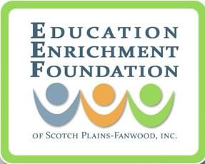

The Education Enrichment Foundation of Scotch Plains-Fanwood Inc. (EEF) will be holding their 6th Annual Beefsteak Dinner and Grant Awards Ceremony fundraiser on February 22, 2019 at the Scotch Plains Italian American Club.

The Mission of the Education Enrichment Foundation of Scotch Plains-Fanwood is to strengthen the learning experience and inspire the students of the Scotch Plains-Fanwood, NJ School District for success. Our Vision is to develop curious, creative and confident learners and leaders.

We accomplish this by funding projects that enrich the curriculum but fall outside of the school district's standard operating budget, encouraging teacher innovation and excellence and engaging the community in fundraising efforts.

Our Beefsteak Dinner helps the EEF to fund grants proposed by district teachers and staff for innovative or creative educational projects, as well as pilots of new after school clubs that support our mission. As always, this year’s event features an Awards Ceremony honoring our 2019-2020 SPF Educator Grant Recipients.

We are asking for your support by donating today. Your contribution, in the form of
merchandise, a gift certificate, a gift basket or other donation, will help make our fundraising a success. Your donation will be featured prominently in our Tricky Tray and your participation will be acknowledged numerous times at the event.

Donations to the EEF are tax deductible! Our tax ID number is 22-3253228. The Education Enrichment Foundation of Scotch Plains-Fanwood Inc. is a 501(c) (3) nonprofit organization.

To fill out our EEF Tricky Tray Request Form visit: www.eefofspf.org/trickytray. For information on Sponsorship Opportunities please visit www.eefofspf.org/sponsorships

Thank you in advance for your generous support! Any donation you provide will help us raise funds for new, innovative and important teacher projects!

Regards,

Anthony Fiore, President
The Education Enrichment Foundation of Scotch Plains-Fanwood
908-543-4SPF
info@eefofspf.org

